2Cars

Game Template

Game documentation and How To guide.

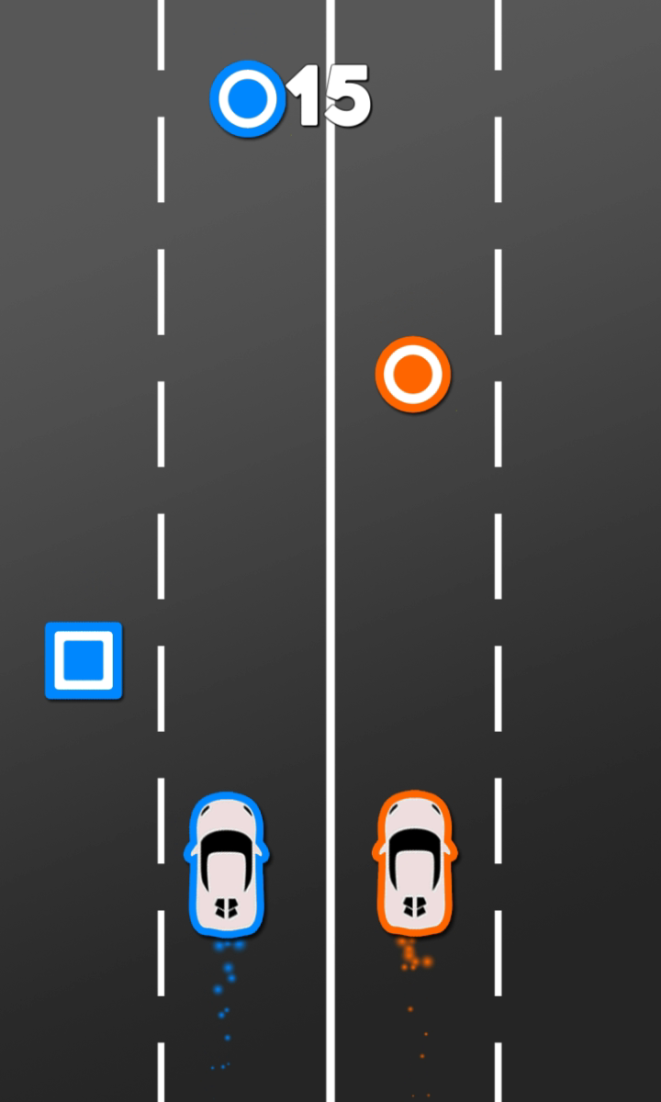

# **2 Cars is a full Unity template ready for release. It is fun arcade game. It is compatible with mobile( iOS and Android) as well as standalone and webplayer.**

**How to Play?**

- Control the Orange car and the blue car at the same time with arrow keys or touch.   
- Collect all the circles and avoid the squares on the road.

**Please rate my file, I’d appreciate it**



Customization Guide

GameController

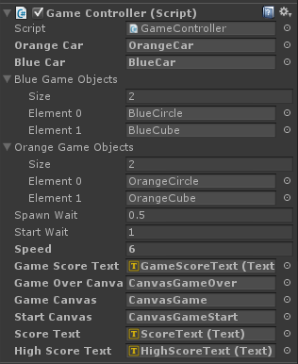

**Orange Car:** Contains the Orange Car GameObject.

**Blue Car:** Contains the Blue Car GameObject.

**Blue GameObject:** Blue cubes & circle prefab is placed here which is created during the gameplay.

**Orange GameObject:** Orange cubes & circle prefab is placed here which is created during the gameplay.

**Spawn Wait:** the wait(in seconds) between two gameObject creation.

**Start Wait:** the wait(in seconds) before initial wave start.

**Speed:** speed at which Circles & Cubes move.

**Game Score Text:** holds the current score text.

**Game Over Canvas:** holds the game over canvas.

**Game Canvas:** holds the Game canvas.

**Start Canvas:** holds the StartGame canvas.

**Score Text:** holds the score text.

**High Score Text:** holds the HighScore text.

For any enquiry contact: **aakarshak51@gmail.com**